Hi Jin,

I was testing the network generation to assign a target node and have run into a couple problems that I wanted to ask about.

Currently, Alex uses total nodes, exposed hosts, subnets and layers to generate a graph. Using 30 nodes with 5 exposed hosts, 5 subnets and 3 layers, this graph is generated:

There’s a couple problem that I see that will cause problems with our goal:

* Not all exposed endpoints are connected to the network
  + Should every exposed node be connected to 1 or more subnet and how is that decided?
* Layers vs depth of target node
  + Should the number of layers change with the depth of the target node?
* Alex’s thesis used: 200 hosts, 50 exposed hosts, 20 subnets and 3 layers
  + ~8 hosts per subnet
  + Forces 1 connection in each subnet from barbasi random generation

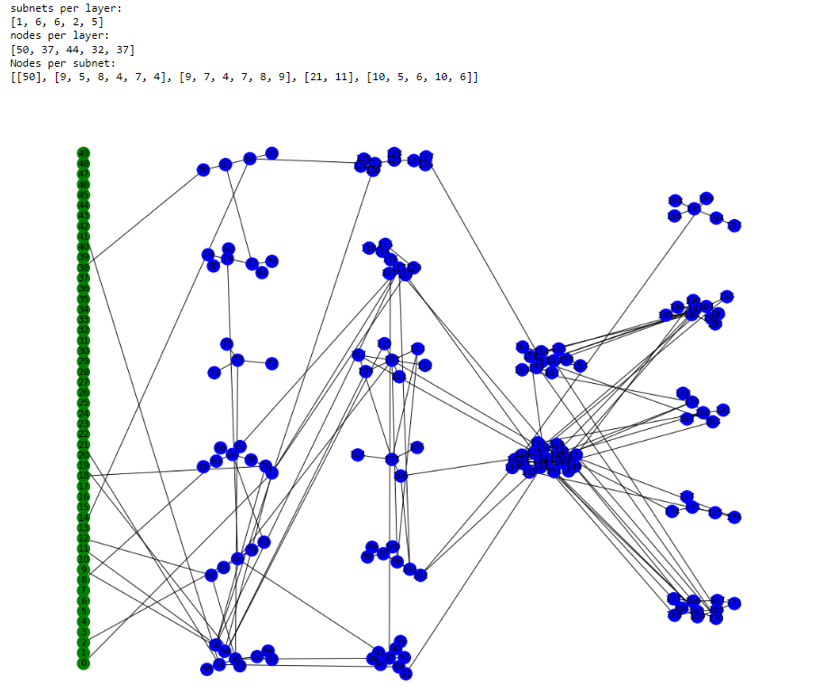

Tag Each layer - > Priotise target tag